

**DELL EMC NetWorker**

**Plugin Configuration Guide**

Contents

Supported Collection Types 2

Data Sources 2

Bocada Plugin Configuration 2

Firewall Ports 3

Collection Requirements 4

NetWorker Client 4

NetWorker Extended Client 4

Policy Data: Remote Filesystem Access 4

Bocada Collection Setup: Server Properties 5

Preferred Method: Jobquery 5

Advanced Property 6

Deprecated Method: GST Database 6

Legacy Method: Savegroup Log (unsupported) 6

Troubleshooting 7

Unable to collect backup job data details older than 3 days 7

Failed to launch mminfo.exe 7

Test Connection Failed: Failed to load policy data using account 9

NetWorker Client Installation Failure 9

Appendix A: Public/Private Key (SSH) 9

Generate a Public/Private Key 10

Modify Key 10

Technical Support 11

# Supported Collection Types

The plugin currently supports the following collection types from NetWorker servers:

|  |  |  |
| --- | --- | --- |
| **Collection Type** | **Supported** | **Description** |
| Backup | ✓ | Collects transactional details about backup, duplication and restore jobs. Example metrics include, start times, durations, bytes, files, errors etc. |
| Storage | ✓ | Collects point-in-time inventory information. Example metrics include, total recoverable gigabytes (storage), media volume count, media volume status, etc. |
| Policy | ✓ | Collects and stores information on policy attributes, schedules, storage units, storage groups, storage lifecycle policies and clients. |

# Data Sources

The plugin relies on the NetWorker data sources as described below. The preferred (default) method of using the jobquery.exe collection method is highlighted in blue.

|  |  |  |  |
| --- | --- | --- | --- |
| **Data Source** | **Collection Type** | **Connection Method** | **Notes** |
| jobquery.exe | Backup | NSR Client | NetWorker Extended Client installed on the Bocada DCS |
| mminfo.exe | Backup, Storage | NSR Client |
| nsradmin.exe | Storage, Policy | NSR Client |
| nsrpolicy.exe | Policy | SMB/SSH | Runs Remotely on NSR |

# Bocada Plugin Configuration

The following procedure is the recommended method for configuring of the Bocada plugin to collect data from supported NetWorker servers

### Checklist

* On the Bocada DCS running collections:
  + Install the NetWorker Client (required for extended client)
  + Install the NetWorker Extended Client
* Policy Collection: Verify SMB or SSH credentials to access the NetWorker server bin path:
  + Default Unix/Linux: */usr/sbin*
  + Default Windows: *c:\Program Files\EMC NetWorker\nsr\bin*
* Verify required firewall ports have been opened

# Firewall Ports

Ports that need to be open at the firewall on the NetWorker server are displayed below. These are inbound direction indicating communication from the public network to the NetWorker server on the private network. The requirements for the preferred (default) method of using the jobquery.exe collection method is highlghed in blue.

|  |  |  |
| --- | --- | --- |
| **Bocada Collection Type** | **Service Port(s)** | **Connection Method** |
| Backup | 7937-9936, 111 (TCP-UDP) | NetWorker Extended Client |
| Storage | 7937-9936, 111 (TCP-UDP) | NetWorker Extended Client |
| Policy (Unix) | 22 (TCP) | SSH2 (Unix) |
| Policy (Windows) | 445 (TCP) | SMB (Windows) |

The current NetWorker Administrator Guide references the default port range as 7937 to 9936, and refers to the EMC NetWorker Security Configuration Guide:

<http://www.emc.com/collateral/TechnicalDocument/docu61097.pdf>

Excerpt:

*NetWorker dynamically opens ports. A NetWorker host can allocate any port in the defined service port range and the NetWorker daemons select the dynamic ports within that range randomly.* ***The default range is 7937-9936*** *and you can narrow or expand this range.*

NetWorker uses two types of TCP/IP ports for inter-process communication: connection ports and service ports. Communication between NetWorker processes is initiated from a connection port on the source host and the communication request is sent to a service port on the destination host where a NetWorker process is listening. If the configured service ports range is not large enough, the associated services and processes cannot communicate through the firewall.

Permitted port ranges are stored in the NSR system port ranges resource in the resource database, /nsr/res/nsrladb on each NetWorker host. The resource is used and managed by nsrexecd. Whenever NetWorker daemons/services are started, nsrexecd is always the first process to start.

# Collection Requirements

## NetWorker Client

The plugin uses the NetWorker command line tools to communicate with the NetWorker server. To make these tools available, install the NetWorker Client software on each Bocada Data Collection Server.

The client software version should be the same as or newer than the version of the NetWorker servers. Do not disable the NetWorker Remote Exec Service installed with the NetWorker Client software. This service is used by the Data Collection Servers to communicate with a NetWorker Server.

## NetWorker Extended Client

In addition to the NetWorker Client, the Extended Client is also needed to collect data against NetWorker servers. Download the appropriate version of the NetWorker Extended Client Software from EMC Online Support and follow the steps in the NetWorker Installation Guide to install or upgrade from an older version.

The NetWorker Extended client installs the following commands used by the Bocada plugin:

* jobquery.exe (Backup update data)
* mminfo.exe (Backup & Storage update data)
* nsradmin.exe (Policy & Storage update data)

## Policy Data: Remote Filesystem Access

SMB access for Windows or SSH access for Unix is needed to run the nsrpolicy.exe command on the NetWorker server in order to collect backup policy information.

### Required

* Access to the NetWorker executables in the server bin path
  + SMB (Windows)
  + SSH2 (UNIX)
* Read permissions via one of the following authentication methods.
  + Password (SMB or SSH2)
  + Public/private key (SSH2)
* Read, write, and execute permissions for the SSH directory on the Bocada DCS (only if using SSH public/private key authentication).

**Note:** SMB collections are possible when connecting via a socks server when the Data Collector has access to the log file locations.

# Bocada Collection Setup: Server Properties

After completing the above prerequisites, NetWorker servers are added to Bocada from the Backup Servers view using the Server Properties as directed below.

## Preferred Method: Jobquery

Chossing the Defaul Jobquery collection method is preferred and supported long term with the NetWorker plugin.

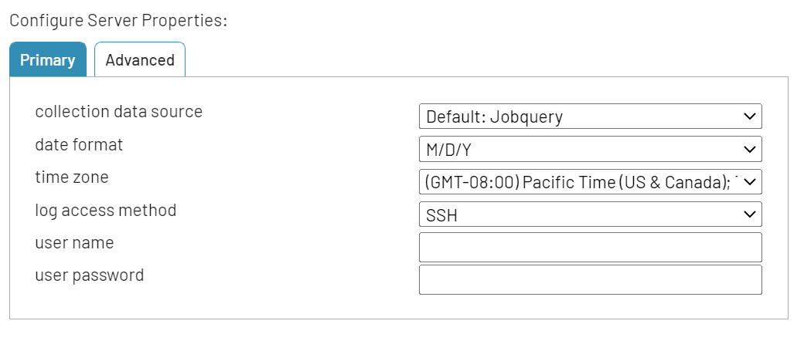

### NetWorker Version

The *Default: Jobquery* method utilizes the jobquery.exe output run against the NetWorker server remotely from the Bocada DCS installed with the NetWorker Extended client.

### Time Zone

Select the time zone where NetWorker server resides.

### Log Access Method

Used for Policy collection, Auto Detect will determine the method of connection based on operating system of the NetWorker server. Explicit selections of SSH, SMB, and Local exist for troubleshooting as needed by Bocada Support. Although *‘SSH’* is displayed in this setting, the Bocada plugin uses SSH2 for connections.

### User Name & Password

Enter the user name and password for an account that has read access to the NetWorker savegrp.log and daemon.log files. The user name should be in one of the formats:

* Domain\User name (Windows servers)
* User name (UNIX/Linux)

## Advanced Server Properties

### Backup job data

While we continue to enhance the new jobquery.exe collection method this can behave differently dependent on the earlier properties:

* *Default: all backup data:* gives the option to add MMINFO data to jobs collected with backup collection methods, like saveset-id, media target destinations for each job, etc.
* *Backups only: no mminfo / media: does not add mminfo data to jobs collected.*
* *mminfo only, no backup failures* is NOT RECOMMENDED as it only captures successful backups that have written to media.

### Server bin path

This is the location of the executable directory where nsrpolicy.exe lives on the NetWorker server. This is required to collect policy information from supported NetWorker servers.

### Jobquery data size multiplier

Default is 1024, but set this value to 1 if the backup job bytecount appears to be to high by a factor of 1024.

### Min media data retention (days)

Number of days back to look in mminfo for media items like Media Pools. If your data collection is missing media pools, set this value higher to pick up media pools with less recent activity. Default is 14 days.

### Use policy targets

You can set this property to *No* only if you don’t want to recollect policy information.

### Use date range in jobquery

Set this property to *No* only if you are running 7.x or older version of Networker server.

## Deprecated Method: GST Database

### NetWorker Version: 9.x GST Database

*Note*: This method should only be configured after attempting the Default: Jobquery method and at the direction of Bocada Support.

## Legacy Method: Savegroup Log (unsupported)

*Note*: This method should only be configured after attempting the Default: Jobquery method and at the direction of Bocada Support.

# Troubleshooting

This section will have troubleshooting tips as they become known.

## Size of backup job data is too high

Set the Advanced Server Property “jobquery data size multiplier” to 1, instead of the default 1024, if your byte counts are too large by a factor of 1024.

## Unable to collect backup job data details older than 3 days

The default retention of detail backup job information in NetWorker is 3 days. Your Backup job data collections will get incomplete data for any collections run older than that.

## Failed to launch mminfo.exe

Should you experience this error:

Error 545: ApplicationException: Failed to launch mminfo.exe

1. Verify that the NetWorker Extended Client is installed on the Bocada Data Collection Server. If not, install the Extended Client and try again.
2. Try running the MMINFO command on the Bocada Data Collection server: Open a command prompt on the Bocada DCS and run the following command (filling in the name of the NetWorker server):

mminfo -s <NetWorker backup server> -v

If the MMINFO command is encountering problems, it may return something like the following:

mminfo: no matches found for the query

This message can indicate that there are no (zero) backups in the NetWorker server (this can occur if the backup volumes contain no backups) or that the mminfo command failed because of a DNS lookup failure.

To debug the MMINFO command, run the command with the -D1 flag:

mminfo -s <NetWorker backup server> -v -D1

If there are issues with DNS, this command will likely return errors such as “Host name verification failed – unknown host” or similar.

1. Try running the MMINFO command on the NetWorker server: On the NetWorker server, open a command prompt and run the same command (again, filling in the correct name for the NetWorker server):

mminfo -s <NetWorker backup server> -v

If this still returns no results, then there are no backup jobs to be found in the media database.

If this returns an error, then the issue is on the NetWorker server – please work with your NetWorker admin to resolve.

1. If the MMINFO command is successful on the NetWorker server but fails from the Bocada DCS, check network connectivity and name resolution (using ping -a and nslookup, with both the IP address and FQDN) from the DCS to the NetWorker server, then perform the same checks from the NetWorker server to the DCS.

## Test Connection Failed: Failed to load policy data using account

When you click on Test connection you should experience this error:

Failed: TestConnectionException: Failed to load policy data using account. IException has been thrown by the target of an invocation

1. Networker plugin policy collection doesn't work when FIPS is enabled.
2. Verify if FIPS is enabled.
3. Go to Local Security Policy, select security options
4. Search for System cryptography: Use FIPS compliant algorithms for encryption, hashing, and signing.
5. Set value from Enabled to Disabled

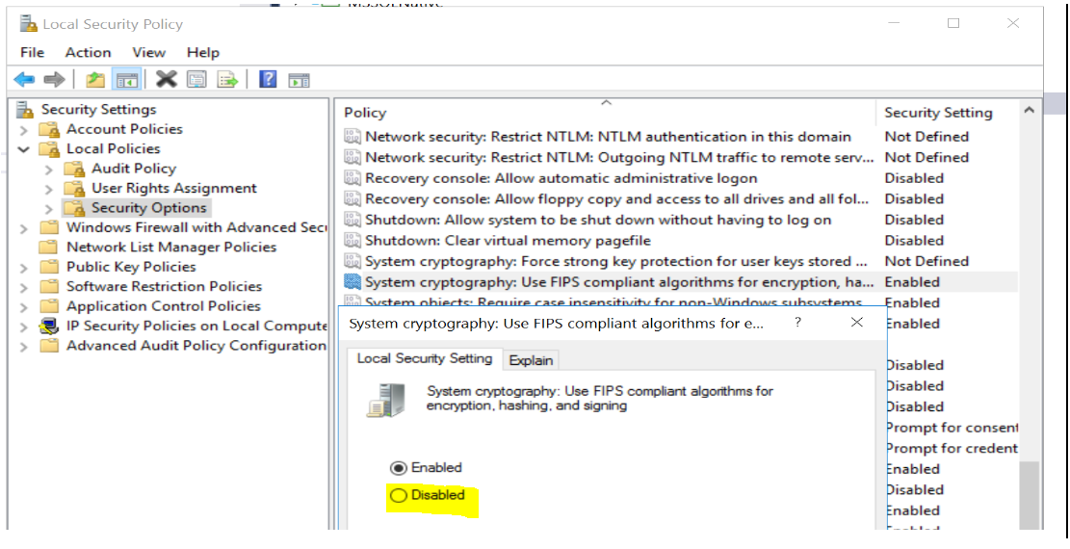

1. Test connection should work.

## NetWorker Client Installation Failure

Should the installation of the NetWorker client fail with a config checker error, please check if the Data Collection Server has access to the internet. Without internet access, the NetWorker client installer cannot check the VMware cert file. The KB article at the location below includes the cert file required and steps required to import the file. Once you complete these steps on any Data Collection Server(s) that do not have internet access, then the install will complete properly: <https://community.emc.com/docs/DOC-63254>

# Appendix A: Public/Private Key (SSH)

**Note:** These steps are only needed if the log files cannot be reached via standard user / password authentication.

The process of using a public/private key with Bocada is a two-step process. Step one is to generate the public/private key. Step two is to use the Bocada broneline.exe utility to modify the key pair into a format compatible with Bocada. The broneline.exe utility transforms a public/private RSA key pair into a single line of text.

We recommend using Cygwin to generate a public/private key so this document uses ssh-keygen.exe as its example. Consult the appropriate software documentation for more information.

## Generate a Public/Private Key

1. Install a SSH2 client on the Bocada Data Collection Server.
2. Create a folder called ssh in a local directory path on the Data Collection Server
3. Open a command prompt and use the following cygwin command:  
   **ssh-keygen -t rsa -f *[local_directory_path]*\ssh*[key_file_name]***
4. When prompted, enter and re-enter the passphrase for the key pair.

The full command is: ssh-keygen[-ceilpqyB] [-t type] [-b bits] [-f file] [-C comment] [-N new-pass] [-P pass]

Where:

* -t = type (format) of key (RSA is the recommended format).
* -f = file name (or path and file name) for the private key.

## Modify Key

Modify the key just created with broneline.exe:

1. Open a command prompt and change directory to the location of the public/private key.
2. Enter the command:

***[*b*ocada_install_dir]*\Bocada\DataCollection\bin\broneline.exe *[key_file_name]* > output**

1. Open the resulting output file in a text editor.
2. Copy and paste the contents into the user name and password fields for the server properties in Add/Edit Server wizard for the server.

# Technical Support

For technical support or a copy of our standard support agreement, please contact us.

**E-mail:** [support@bocada.com](mailto:support@bocada.com)

**Support Portal:** <https://bocada-support.force.com/>

**Phone:** +1-425-898-2400